UNIT -1

1. EXPLAIN VON NEWMANN MODEL WITH DIAGRAM?

ANS - Von-Neumann proposed his computer architecture design in 1945 which was later known as Von-Neumann Architecture. It consisted of a Control Unit, Arithmetic, and Logical Memory Unit (ALU), Registers and Inputs/Outputs.

Von Neumann architecture is based on the stored-program computer concept, where instruction data and program data are stored in the same memory. This design is still used in most computers produced today.

### A Von Neumann-based computer:

* Uses a single processor
* Uses one memory for both instructions and data.
* Executes programs following the fetch-decode-execute cycle

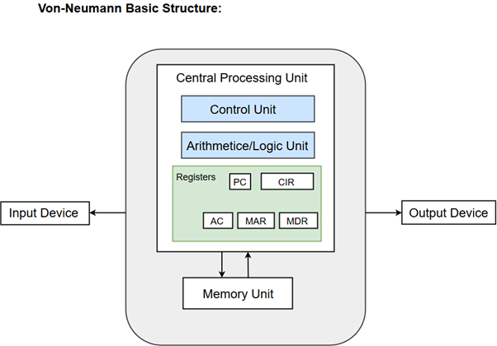

## Components of Von-Neumann Model:

* Central Processing Unit
* Buses
* Memory Unit

## Central Processing Unit

The part of the Computer that performs the bulk of data processing operations is called the Central Processing Unit and is referred to as the CPU.

The Central Processing Unit can also be defined as an electric circuit responsible for executing the instructions of a computer program.

The CPU performs a variety of functions dictated by the type of instructions that are incorporated in the computer.

The major components of CPU are Arithmetic and Logic Unit (ALU), Control Unit (CU) and a variety of registers.

### Arithmetic and Logic Unit (ALU)

The Arithmetic and Logic Unit (ALU) performs the required micro-operations for executing the instructions. In simple words, ALU allows arithmetic (add, subtract, etc.) and logic (AND, OR, NOT, etc.) operations to be carried out.

### Control Unit

The Control Unit of a computer system controls the operations of components like ALU, memory and input/output devices.

The Control Unit consists of a program counter that contains the address of the instructions to be fetched and an instruction register into which instructions are fetched from memory for execution.

### Registers

Registers refer to high-speed storage areas in the CPU. The data processed by the CPU are fetched from the registers.

Following is the list of registers that plays a crucial role in data processing.

|  |  |
| --- | --- |
| Registers | Description |
| MAR (Memory Address Register) | This register holds the memory location of the data that needs to be accessed. |
| MDR (Memory Data Register) | This register holds the data that is being transferred to or from memory. |
| AC (Accumulator) | This register holds the intermediate arithmetic and logic results. |
| PC (Program Counter) | This register contains the address of the next instruction to be executed. |
| CIR (Current Instruction Register) | This register contains the current instruction during processing. |

## Buses

Buses are the means by which information is shared between the registers in a multiple-register configuration system.

A bus structure consists of a set of common lines, one for each bit of a register, through which binary information is transferred one at a time. Control signals determine which register is selected by the bus during each particular register transfer.

Von-Neumann Architecture comprised of three major bus systems for data transfer.

|  |  |
| --- | --- |
| Bus | Description |
| Address Bus | Address Bus carries the address of data (but not the data) between the processor and the memory. |
| Data Bus | Data Bus carries data between the processor, the memory unit and the input/output devices. |
| Control Bus | Control Bus carries signals/commands from the CPU. |

## Memory Unit

A memory unit is a collection of storage cells together with associated circuits needed to transfer information in and out of the storage. The memory stores binary information in groups of bits called words. The internal structure of a memory unit is specified by the number of words it contains and the number of bits in each word.

**Two major types of memories are used in computer systems:**

1. RAM (Random Access Memory)
2. ROM (Read-Only Memory)

2. TYPES OF ADDRESSING MODES?

ANS - Types of Addressing Modes

Below we have discussed different types of addressing modes one by one:

### Immediate Mode

In this mode, the operand is specified in the instruction itself. An immediate mode instruction has an operand field rather than the address field.

For example: ADD 7, which says Add 7 to contents of accumulator. 7 is the operand here.

### Register Mode

In this mode the operand is stored in the register and this register is present in CPU. The instruction has the address of the Register where the operand is stored.

### Register Indirect Mode

In this mode, the instruction specifies the register whose contents give us the address of operand which is in memory. Thus, the register contains the address of operand rather than the operand itself.

Auto Increment/Decrement Mode

In this the register is incremented or decremented after or before its value is used.

### Direct Addressing Mode

In this mode, effective address of operand is present in instruction itself.

* Single memory reference to access data.
* No additional calculations to find the effective address of the operand.

**For Example:** ADD R1, 4000 - In this the 4000 is effective address of operand.

### Indirect Addressing

In this, the address field of instruction gives the address where the effective address is stored in memory. This slows down the execution, as this includes multiple memory lookups to find the operand.

### Displacement Addressing Mode

In this the contents of the indexed register is added to the Address part of the instruction, to obtain the effective address of operand.

EA = A + (R), In this the address field holds two values, A(which is the base value) and R(that holds the displacement), or vice versa.

### Relative Addressing Mode

It is a version of Displacement addressing mode.

In this the contents of PC(Program Counter) is added to address part of instruction to obtain the effective address.

EA = A + (PC), where EA is effective address and PC is program counter.

The operand is A cells away from the current cell(the one pointed to by PC)

### Base Register Addressing Mode

It is again a version of Displacement addressing mode. This can be defined as EA = A + (R), where A is displacement and R holds pointer to base address.

### Stack Addressing Mode

In this mode, operand is at the top of the stack. For example: ADD, this instruction will *POP* top two items from the stack, add them, and will then *PUSH* the result to the top of the stack.

3. INSTRUCTION CYCLE ?

ANS - Instruction Cycle

An instruction cycle, also known as **fetch-decode-execute cycle** is the basic operational process of a computer. This process is repeated continuously by CPU from boot up to shut down of computer.

Following are the steps that occur during an instruction cycle:

### 1. Fetch the Instruction

The instruction is fetched from memory address that is stored in PC(Program Counter) and stored in the instruction register IR. At the end of the fetch operation, PC is incremented by 1 and it then points to the next instruction to be executed.

### 2. Decode the Instruction

The instruction in the IR is executed by the decoder.

### 3. Read the Effective Address

If the instruction has an indirect address, the effective address is read from the memory. Otherwise operands are directly read in case of immediate operand instruction.

### 4. Execute the Instruction

The Control Unit passes the information in the form of control signals to the functional unit of CPU. The result generated is stored in main memory or sent to an output device.

The cycle is then repeated by fetching the next instruction. Thus in this way the instruction cycle is repeated continuously.

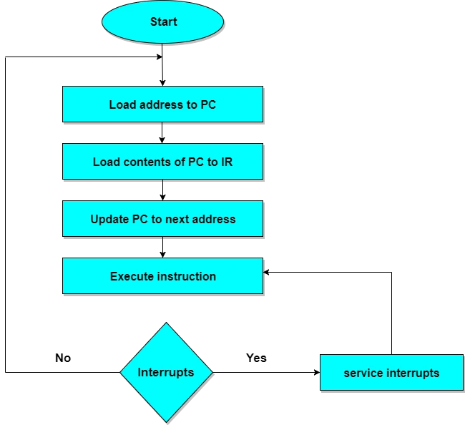

4 BUS STRUCTURE?

ANS - A Bus is a collection of wires that connects several devices.

Buses are used to send control signals and data between the processor and other components

This is to achieve a  reasonable speed of operation.

In computer system all the peripherals are connected to microprocessor through Bus.

Types of Bus structure:

1. Address bus
2. Data bus
3. Control bus

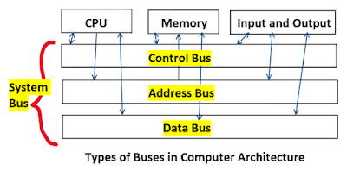

1. Address Bus:

1. Address bus carry the memory address while reading from writing into memory.
2. Address bus caary I/O post address or device address from I/O port.
3. In uni-directional address bu only the CPU could  send address and other units could not address the microprocessor.
4. Now a days computers are haing bi-directional address bus.

2. Data Bus:

1. Data bus carry the data.
2. Data bus is a bidirectional bus.
3. Data bus fetch the instructions from memory.
4. Data bus used to store the result of an instruction into memory.
5. Data bus carry commands to an I/O device controller or port.
6. Data bus carry data from a device controller or port.
7. Data bus issue data to a device controller or port.

3. Control Bus:

Different types of control signals are used in a bus:

1. Memory Read: This signal, is issued by the CPU or DMA controller when performing  a read operation with the memory.
2. MemoryWrite: This signal isissued by the CPU or DMAcontroller when performing  a write operation with the memory.
3. I/O Read: This signal isissued by the CPU when it is reading from an input port.
4. I/O Write: This signal is issued by the CPU when writing into an output port.
5. Ready: The ready is an input signal to the CPU

5. WHAT IS MAR AND PC?

ANS - the Memory Address Register (MAR) is the CPU register that either stores the memory address from which data will be fetched to the CPU or theaddress to which data will be sent and stored. In other words, MAR holds the memory location of data that needs to be accessed.

A program counter (PC) is a [register](https://www.techtarget.com/whatis/definition/register) in a computer [processor](https://www.techtarget.com/whatis/definition/processor) that contains the address (location) of the [instruction](https://www.techtarget.com/whatis/definition/instruction) being executed at the current time. As each instruction gets [fetched](https://searchsqlserver.techtarget.com/definition/fetch), the program counter increases its stored value by 1. After each instruction is fetched, the program counter points to the next instruction in the sequence. When the computer restarts or is reset, the program counter normally reverts to 0

UNIT -2

1. CONTROL UNIT ORGANIZATION?

**Control Unit Organization**

**The Control Unit is the unit in the CPU, which controls the various components like input  & output devices, logic unit and memory. The Control Unit is the circuitry that controls or directs the component’s operations and tells them how to respond to the instruction received from the program.**

### Functions of the control unit

**CU's main function is to direct the operations during the execution of a program by the processor.**

**The control unit converts the input into control signals sent to different components and registers to execute its functioning.**

**The Control Unit cannot store or process the data; it just directs the data signals.**

**Control unit directs working of all its components. It provides direction to the control signals and send them to the appropriate component to execute the instruction. Control unit components are:- control signal within the CPU, instruction register, input flags, control bus, clock signals, control signals to/from the bus.**

### Design of Control Unit

**Every CPU can be designed in a different- different way, same with the control unit. Control unit can be designed in two possible best ways.**

1. **Hardwired Control Unit**
2. **Micro-programmed Control Unit**

### Hardwired Control Unit

**As the name defined hardwired control unit, going to design the control unit by using the hardware (circuits). The control logic is implemented with Gates, flip-flops, decoders, and other digital circuits in this type.**

“***Control logic is the unit which generates the control signals which are implemented using the hardware that’s why it is called as hardwired control unit.”***

**Advantage:  Hardware is always faster. Due to this, it can be optimized to produce a faster mode of operation. It generates the fastest control signal.**

**Disadvantage: a) If CPU design is very complicated or very much modern, hardwired control is difficult to implement**

**b) Rearranging the wires among various components is difficult.**

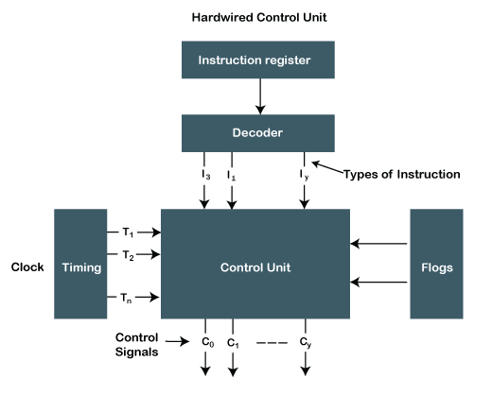

### Micro-programmed Control Unit

**In this control, logic is implemented with micro-programs. That's why it is called a micro-programmed control unit. It’s a midway between hardware and software.**

“**All possible control words are stored in a memory because it is a part of control unit) and based on the requirements, the specific control word is fetched from memory, then its signals are sent to different components.”**

**In this type, the control word is used to store the control signals encoded during the execution of a program and control words are stored in the memory. Memory can be easily changed; we can change the value (0 or 1) in the control word, enabling and disabling signals. We do not need to change the whole control word format as it can work on a variable format of 16-64 bit, or we can easily update the control logic.**

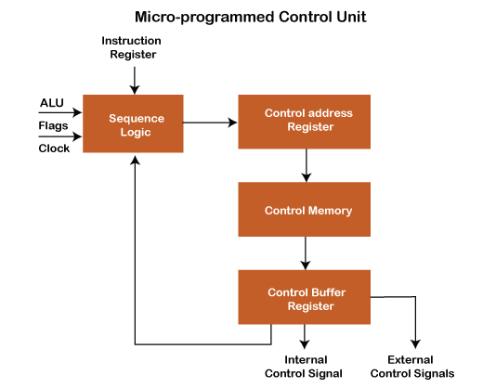

2. micro instruction encoding?

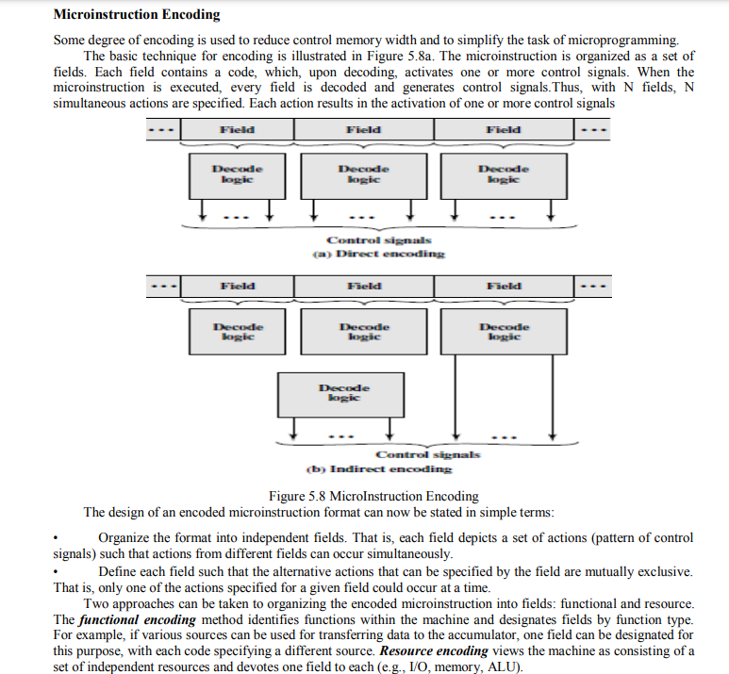3. differnec between horizontal and vertical micro instructions?

Ans - Difference between Horizontal and Vertical micro-programmed Control Unit:

| **S. No** | **Horizontal µ-programmed CU** | **Vertical µ-programmed CU** |
| --- | --- | --- |
| 1. | It supports longer control word. | It supports shorter control word. |
| 2. | It allows a higher degree of parallelism. If degree is n, then n Control Signals are enabled at a time. | It allows a low degree of parallelism i.e., the degree of parallelism is either 0 or 1. |
| 3. | No additional hardware is required. | Additional hardware in the form of decoders is required to generate control signals. |
| 4. | It is faster than a Vertical micro-programmed control unit. | it is slower than a Horizontal micro-programmed control unit. |
| 5. | It is less flexible than a Vertical micro-programmed control unit. | It is more flexible than a Horizontal micro-programmed control unit. |
| 6. | A horizontal micro-programmed control unit uses horizontal micro-instruction, where every bit in the control field attaches to a control line. | A vertical micro-programmed control unit uses vertical micro-instruction, where a code is used for each action to be performed and the decoder translates this code into individual control signals. |
| 7. | The horizontal micro-programmed control unit makes less use of ROM encoding than the vertical micro-programmed control unit. |  |

UNIT -3

1. DESIGN ARITHMETIC LOGIC UNIT

ANS - Inside a computer, there is an Arithmetic Logic Unit (ALU), which is capable of performing logical operations (e.g. AND, OR, Ex-OR, Invert etc.) in addition to the arithmetic operations (e.g. Addition, Subtraction etc.). The control unit supplies the data required by the ALU from memory, or from input devices, and directs the ALU to perform a specific operation based on the instruction fetched from the memory. ALU is the “calculator” portion of the computer.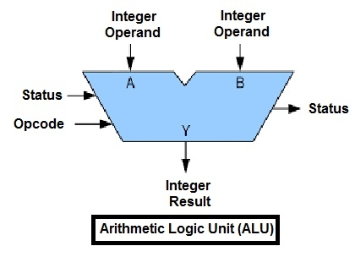

An arithmetic logic unit(ALU) is a major component of the central processing unit of the a computer system. It does all processes related to arithmetic and logic operations that need to be done on instruction words. In some microprocessor architectures, the ALU is divided into the arithmetic unit (AU) and the logic unit (LU).

An ALU can be designed by engineers to calculate many different operations. When the operations become more and more complex, then the ALU will also become more and more expensive and also takes up more space in the CPU and dissipates more heat. That is why engineers make the ALU powerful enough to ensure that the CPU is also powerful and fast, but not so complex as to become prohibitive in terms of cost and other disadvantages.

ALU is also known as an Integer Unit (IU). The arithmetic logic unit is that part of the CPU that handles all the calculations the CPU may need. Most of these operations are logical in nature. Depending on how the ALU is designed, it can make the CPU more powerful, but it also consumes more energy and creates more heat. Therefore, there must be a balance between how powerful and complex the ALU is and how expensive the whole unit becomes. This is why faster CPUs are more expensive, consume more power and dissipate more heat.

Different operation as carried out by ALU can be categorized as follows –

* **logical operations** − These include operations like AND, OR, NOT, XOR, NOR, NAND, etc.
* **Bit-Shifting Operations** − This pertains to shifting the positions of the bits by a certain number of places either towards the right or left, which is considered a multiplication or division operations.
* **Arithmetic operations** − This refers to bit addition and subtraction. Although multiplication and division are sometimes used, these operations are more expensive to make. Multiplication and subtraction can also be done by repetitive additions and subtractions respectively.

2. CISC AND RISC

ANS - Reduced Instruction Set Architecture (RISC) –   
The main idea behind this is to make hardware simpler by using an instruction set composed of a few basic steps for loading, evaluating, and storing operations just like a load command will load data, a store command will store the data.

Complex Instruction Set Architecture (CISC) –   
The main idea is that a single instruction will do all loading, evaluating, and storing operations just like a multiplication command will do stuff like loading data, evaluating, and storing it, hence it’s complex.

Both approaches try to increase the CPU performance

* RISC: Reduce the cycles per instruction at the cost of the number of instructions per program.
* CISC: The CISC approach attempts to minimize the number of instructions per program but at the cost of an increase in the number of cycles per instruction.

Earlier when programming was done using assembly language, a need was felt to make instruction do more tasks because programming in assembly was tedious and error-prone due to which CISC architecture evolved but with the uprise of high-level language dependency on assembly reduced RISC architecture prevailed.

Characteristic of RISC –

1. Simpler instruction, hence simple instruction decoding.
2. Instruction comes undersize of one word.
3. Instruction takes a single clock cycle to get executed.
4. More general-purpose registers.
5. Simple Addressing Modes.
6. Fewer Data types.
7. A pipeline can be achieved.

Characteristic of CISC –

1. Complex instruction, hence complex instruction decoding.
2. Instructions are larger than one-word size.
3. Instruction may take more than a single clock cycle to get executed.
4. Less number of general-purpose registers as operations get performed in memory itself.
5. Complex Addressing Modes.
6. More Data types.

3. INSTRUCTION PIPELINING?

ANS - Instruction Pipeline

Pipeline processing can occur not only in the data stream but in the instruction stream as well.

Most of the digital computers with complex instructions require instruction pipeline to carry out operations like fetch, decode and execute instructions.

In general, the computer needs to process each instruction with the following sequence of steps.

1. Fetch instruction from memory.
2. Decode the instruction.
3. Calculate the effective address.
4. Fetch the operands from memory.
5. Execute the instruction.
6. Store the result in the proper place.

Each step is executed in a particular segment, and there are times when different segments may take different times to operate on the incoming information. Moreover, there are times when two or more segments may require memory access at the same time, causing one segment to wait until another is finished with the memory.

The organization of an instruction pipeline will be more efficient if the instruction cycle is divided into segments of equal duration. One of the most common examples of this type of organization is a **Four-segment instruction pipeline.**

A **four-segment instruction** pipeline combines two or more different segments and makes it as a single one. For instance, the decoding of the instruction can be combined with the calculation of the effective address into one segment.

The following block diagram shows a typical example of a four-segment instruction pipeline. The instruction cycle is completed in four segments.

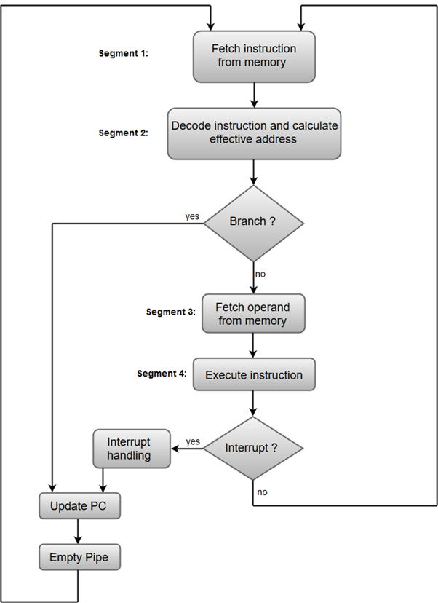

#### Segment 1:

The instruction fetch segment can be implemented using first in, first out (FIFO) buffer.

#### Segment 2:

The instruction fetched from memory is decoded in the second segment, and eventually, the effective address is calculated in a separate arithmetic circuit.

#### Segment 3:

An operand from memory is fetched in the third segment.

#### Segment 4:

The instructions are finally executed in the last segment of the pipeline organization.

UNIT –4

1. WHAT IS DMA CONTROLLER AND ITS DIAGRAM?

ANS - **Direct Memory Access (DMA) :**

[DMA](https://www.geeksforgeeks.org/direct-memory-access-with-dma-controller-8257-8237/) Controller is a hardware device that allows I/O devices to directly access memory with less participation of the processor. DMA controller needs the same old circuits of an interface to communicate with the CPU and Input/Output devices.

Fig-1 below shows the block diagram of the DMA controller. The unit communicates with the CPU through data bus and control lines. Through the use of the address bus and allowing the DMA and RS register to select inputs, the register within the DMA is chosen by the CPU. RD and WR are two-way inputs. When BG (bus grant) input is 0, the CPU can communicate with DMA registers. When BG (bus grant) input is 1, the CPU has relinquished the buses and DMA can communicate directly with the memory.

[**DMA controller registers**](https://www.geeksforgeeks.org/internal-registers-of-dma-controller/) **:**

The DMA controller has three registers as follows.

* **Address register –** It contains the address to specify the desired location in memory.
* **Word count register –** It contains the number of words to be transferred.
* **Control register –** It specifies the transfer mode.

**Note –**

All registers in the DMA appear to the [CPU](https://www.geeksforgeeks.org/difference-between-cpu-and-gpu/) as I/O interface registers. Therefore, the CPU can both read and write into the DMA registers under program control via the data bus.

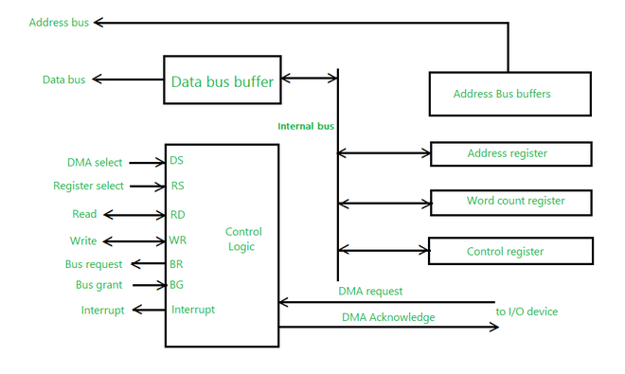

1. DATA COMMUNICATION AND ITS COMPONENTS?

ANS - **Data communication** is nothing but the exchange of data between any two devices via transmission media.

## Components

There are five main components of data communication and they are explained below −

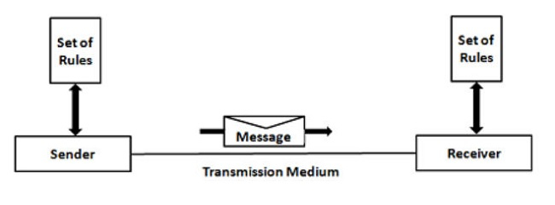

### Message

This is the most valuable asset of a system for data communication. The message actually refers to data that is to be shared or a piece of information. A message is in any form, like a text file, an audio file, a video file, and so on.

### Sender

Someone who can play the role of a source must be there to pass messages from source to destination. The sender plays a part of the data communication device root. A device that sends data messages is easy. The node can be a computer, mobile device, telephone, laptop, video camera, workstation, etc.

### Receiver

It is the destination where messages sent by the source have finally arrived. It is a message-receiving system. The receiver is in the form of a computer, cell phone, workstation, etc., identical to the sender.

### Transmission Medium

There must be something in the entire data communication process that could act as a bridge between sender and receiver. The transmission is the physical path from the sender to the recipient where the information or message passes.

The examples of transmission medium are twisted pair cable, fibre optic cable, radio waves, microwaves, etc. The transmission medium could be guided (with wires) or unguided (without wires).

### Protocol (set of rules)

Different sets of rules have already been designed by the designers of communication systems to control data communication, reflecting a sort of agreement between communicating devices. These are characterized as protocols.

The protocol is also called as a set of rules regulating data communication. If two separate devices are connected, but there is no protocol between them, there will be no contact between the two devices of any sort.

1. INPUT / OUTPUT PROCESSOR?

ANS - An input-output processor (IOP) is a processor with direct memory access capability. In this, the computer system is divided into a memory unit and number of processors.

Each IOP controls and manage the input-output tasks. The IOP is similar to CPU except that it handles only the details of I/O processing. The IOP can fetch and execute its own instructions. These IOP instructions are designed to manage I/O transfers only.

## Block Diagram Of I/O Processor

Below is a block diagram of a computer along with various I/O Processors. The memory unit occupies the central position and can communicate with each processor.

The CPU processes the data required for solving the computational tasks. The IOP provides a path for transfer of data between peripherals and memory. The CPU assigns the task of initiating the I/O program.

The IOP operates independent from CPU and transfer data between peripherals and memory.

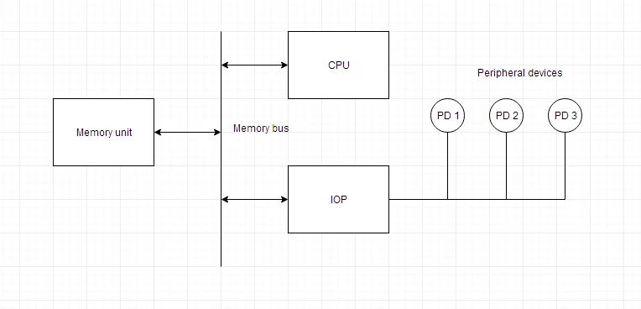

The communication between the IOP and the devices is similar to the program control method of transfer. And the communication with the memory is similar to the direct memory access method.

In large scale computers, each processor is independent of other processors and any processor can initiate the operation.

The CPU can act as master and the IOP act as slave processor. The CPU assigns the task of initiating operations but it is the IOP, who executes the instructions, and not the CPU. CPU instructions provide operations to start an I/O transfer. The IOP asks for CPU through interrupt.

Instructions that are read from memory by an IOP are also called *commands* to distinguish them from instructions that are read by CPU. Commands are prepared by programmers and are stored in memory. Command words make the program for IOP. CPU informs the IOP where to find the commands in memory.

1. WHAT IS INERRUPTS, PRIORITY INTERRUPTS AND ITS TYPES?

ANS - Data transfer between the CPU and the peripherals is initiated by the CPU. But the CPU cannot start the transfer unless the peripheral is ready to communicate with the CPU. When a device is ready to communicate with the CPU, it generates an interrupt signal. A number of input-output devices are attached to the computer and each device is able to generate an interrupt request.

The main job of the interrupt system is to identify the source of the interrupt. There is also a possibility that several devices will request simultaneously for CPU communication. Then, the interrupt system has to decide which device is to be serviced first.

## Priority Interrupt

A priority interrupt is a system which decides the priority at which various devices, which generates the interrupt signal at the same time, will be serviced by the CPU. The system has authority to decide which conditions are allowed to interrupt the CPU, while some other interrupt is being serviced. Generally, devices with high speed transfer such as *magnetic disks* are given high priority and slow devices such as *keyboards* are given low priority.

When two or more devices interrupt the computer simultaneously, the computer services the device with the higher priority first.

## Types of Interrupts:

Following are some different types of interrupts:

### Hardware Interrupts

When the signal for the processor is from an external device or hardware then this interrupts is known as **hardware interrupt**.

Let us consider an example: when we press any key on our keyboard to do some action, then this pressing of the key will generate an interrupt signal for the processor to perform certain action. Such an interrupt can be of two types:

* **Maskable Interrupt**
* The hardware interrupts which can be delayed when a much high priority interrupt has occurred at the same time.
* **Non Maskable Interrupt**
* The hardware interrupts which cannot be delayed and should be processed by the processor immediately.

### Software Interrupts

The interrupt that is caused by any internal system of the computer system is known as a **software interrupt**. It can also be of two types:

* **Normal Interrupt**
* The interrupts that are caused by software instructions are called **normal software interrupts**.
* **Exception**
* Unplanned interrupts which are produced during the execution of some program are called **exceptions**, such as division by zero.

## Daisy Chaining Priority

This way of deciding the interrupt priority consists of serial connection of all the devices which generates an interrupt signal. The device with the highest priority is placed at the first position followed by lower priority devices and the device which has lowest priority among all is placed at the last in the chain.

UNIT – 5

1. STRUCTURE OF MULTIPROCESSOR

Ans - **Multiprocessor:**  
**A Multiprocessor is a computer system with two or more central processing units (CPUs) share full access to a common RAM. The main objective of using a multiprocessor is to boost the system’s execution speed, with other objectives being fault tolerance and application matching.**

There are two types of multiprocessors, one is called shared memory multiprocessor and another is distributed memory multiprocessor. In shared memory multiprocessors, all the CPUs shares the common memory but in a distributed memory multiprocessor, every CPU has its own private memory.

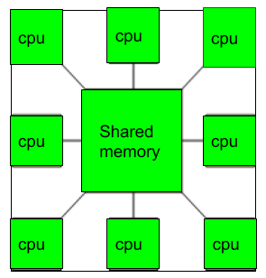

**Applications of Multiprocessor –**

1. As a uniprocessor, such as single instruction, single data stream (SISD).
2. As a multiprocessor, such as single instruction, multiple data stream (SIMD), which is usually used for vector processing.
3. Multiple series of instructions in a single perspective, such as multiple instruction, single data stream (MISD), which is used for describing hyper-threading or pipelined processors.
4. Inside a single system for executing multiple, individual series of instructions in multiple perspectives, such as multiple instruction, multiple data stream (MIMD).

**Benefits of using a Multiprocessor –**

* Enhanced performance.
* Multiple applications.
* Multi-tasking inside an application.
* High throughput and responsiveness.
* Hardware sharing among CPUs.

# 2. memory organization, auxillary memory, cache memory, associative memory, memory heirarchy

Ans -

# - Memory Organization in Computer Architecture

A memory unit is the collection of storage units or devices together. The memory unit stores the binary information in the form of bits. Generally, memory/storage is classified into 2 categories:

* **Volatile Memory**: This loses its data, when power is switched off.
* **Non-Volatile Memory**: This is a permanent storage and does not lose any data when power is switched off.

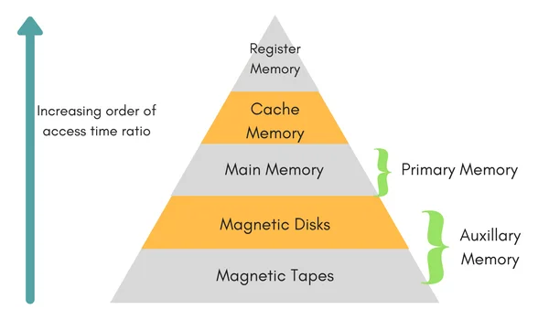

## Memory Hierarchy

The total memory capacity of a computer can be visualized by hierarchy of components. The memory hierarchy system consists of all storage devices contained in a computer system from the slow Auxiliary Memory to fast Main Memory and to smaller Cache memory.

**Auxillary memory** access time is generally **1000 times** that of the main memory, hence it is at the bottom of the hierarchy.

The **main memory** occupies the central position because it is equipped to communicate directly with the CPU and with auxiliary memory devices through Input/output processor (I/O).

When the program not residing in main memory is needed by the CPU, they are brought in from auxiliary memory. Programs not currently needed in main memory are transferred into auxiliary memory to provide space in main memory for other programs that are currently in use.

The **cache memory** is used to store program data which is currently being executed in the CPU. Approximate access time ratio between cache memory and main memory is about **1 to 7~10**

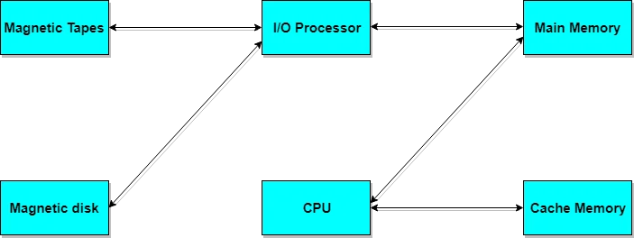

## Memory Access Methods

Each memory type, is a collection of numerous memory locations. To access data from any memory, first it must be located and then the data is read from the memory location. Following are the methods to access information from memory locations:

1. **Random Access**: Main memories are random access memories, in which each memory location has a unique address. Using this unique address any memory location can be reached in the same amount of time in any order.
2. **Sequential Access**: This methods allows memory access in a sequence or in order.
3. **Direct Access**: In this mode, information is stored in tracks, with each track having a separate read/write head.

## Main Memory

The memory unit that communicates directly within the CPU, Auxillary memory and Cache memory, is called main memory. It is the central storage unit of the computer system. It is a large and fast memory used to store data during computer operations. Main memory is made up of **RAM** and **ROM**, with RAM integrated circuit chips holing the major share.

* RAM: Random Access Memory
  + **DRAM**: Dynamic RAM, is made of capacitors and transistors, and must be refreshed every 10~100 ms. It is slower and cheaper than SRAM.
  + **SRAM**: Static RAM, has a six transistor circuit in each cell and retains data, until powered off.
  + **NVRAM**: Non-Volatile RAM, retains its data, even when turned off. Example: Flash memory.
* ROM: Read Only Memory, is non-volatile and is more like a permanent storage for information. It also stores the **bootstrap loader** program, to load and start the operating system when computer is turned on. **PROM**(Programmable ROM), **EPROM**(Erasable PROM) and **EEPROM**(Electrically Erasable PROM) are some commonly used ROMs.

## Auxiliary Memory

Devices that provide backup storage are called auxiliary memory. **For example:** Magnetic disks and tapes are commonly used auxiliary devices. Other devices used as auxiliary memory are magnetic drums, magnetic bubble memory and optical disks.

It is not directly accessible to the CPU, and is accessed using the Input/Output channels.

### Cache Memory

The data or contents of the main memory that are used again and again by CPU, are stored in the cache memory so that we can easily access that data in shorter time.

Whenever the CPU needs to access memory, it first checks the cache memory. If the data is not found in cache memory then the CPU moves onto the main memory. It also transfers block of recent data into the cache and keeps on deleting the old data in cache to accomodate the new one.

## Associative Memory

It is also known as **content addressable memory (CAM)**. It is a memory chip in which each bit position can be compared. In this the content is compared in each bit cell which allows very fast table lookup. Since the entire chip can be compared, contents are randomly stored without considering addressing scheme. These chips have less storage capacity than regular memory chips.

1. What is memory allocation? Differnece between contiguous and non-contiguous memeory allocation? What is swapping ?

Ans –

Memory allocation is the process of reserving a partial or complete portion of computer memory for the execution of programs and processes. Memory allocation is achieved through a process known as memory management.

|  |  |  |
| --- | --- | --- |
| S.NO. | Contiguous Memory Allocation | Non-Contiguous Memory Allocation |
| 1. | Contiguous memory allocation allocates consecutive blocks of memory to a file/process. | Non-Contiguous memory allocation allocates separate blocks of memory to a file/process. |
| 2. | Faster in Execution. | Slower in Execution. |
| 3. | It is easier for the OS to control. | It is difficult for the OS to control. |
| 4. | Overhead is minimum as not much address translations are there while executing a process. | More Overheads are there as there are more address translations. |
| 5. | Both Internal fragmentation and external fragmentation occurs in Contiguous memory allocation method. | Only External fragmentation occurs in Non-Contiguous memory allocation method. |
| 6. | It includes single partition allocation and multi-partition allocation. | It includes paging and segmentation. |
| 7. | Wastage of memory is there. | No memory wastage is there. |
| 8. | In contiguous memory allocation, swapped-in processes are arranged in the originally allocated space. | In non-contiguous memory allocation, swapped-in processes can be arranged in any place in the memory. |

### Swapping :

When a process is executed it must have resided in memory. Swapping is a process of swap a process temporarily into a secondary memory from the main memory, which is fast as compared to secondary memory. A swapping allows more processes to be run and can be fit into memory at one time.